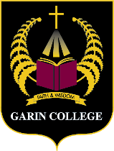
KĀRETI O GARIN

“Te waahi tapu o te ako i te Papa Garin - The sacred learning grounds of Father Garin.
Archdeacon Harvey Ruru – 2023

Invitation to Opening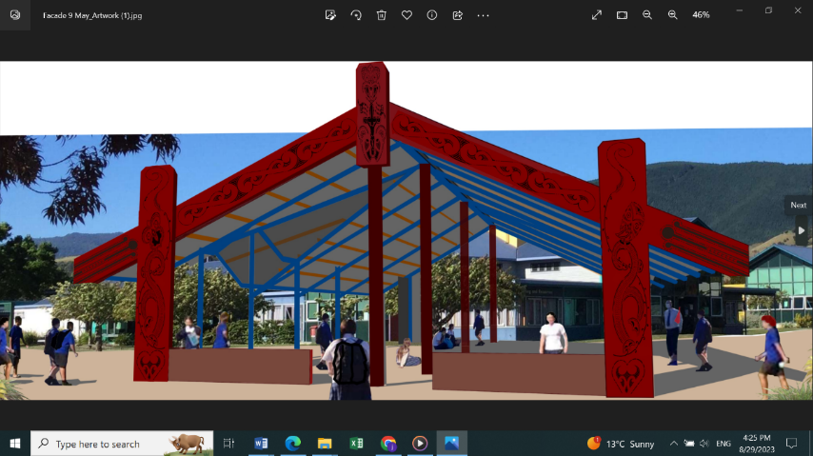

Te Wharemaru o Garin
‘Our place of Shelter and Protection - Protecting our story our curriculum’

We are delighted to welcome all

Learner’s and Whānau
Parish and Community
Teacher’s and Support Staff

to the opening of Te Wharemaru o Garin

Monday 30 October 2023 - Garin College
6am - Kawanga Whare - Karakia and Blessing
8.40am - 9.am - Official Opening

“Te Wharemaru O Garin is our new, exciting and incredibly significant property development at Garin College for all ākonga, whānau and community. The many design elements embedded within “Te Wharemaru O Garin embrace Garin’s local curriculum of faith and culture informing life, learning and wairua within Garin College. Te Wharemaru is placed central at the entrance, welcoming all into the community and wairua of Garin.
Te Wharemaru is at the location of the Garin College opening powhiri on the first school day in 2002 and covers the traditional social gathering place of learners as they greet each other to start their day and farewell each other at the end of the day. Te Wharemaru will provide shelter and protection against the elements.

